|  |
| --- |
| **NHS Fife**  **Clinical Psychology**  **Adult Learning Disabilities Service** |
| **Advice1** |
| **What do Psychologists do?** |
|  |

**Psychologists can help you with your feelings.**



Feeling worried



Feeling sad



Feeling scared



Feeling angry

**Psychologists can also help with**



Memory or thinking problems



Working out what you want and need.



Relationship problems

**Psychologists can work in different ways**



Sometimes we work with you



Sometimes we work with the people who support you

We might only see you one time





We might see you lots of times

**Psychologists work in different places**



At a hospital or clinic

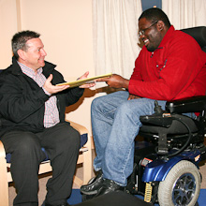

At your home



At a day centre





**If you want to know more, contact us at:**

**Phone:** 01383 565210

Clinical Psychology Department

Lynebank Hospital

Halbeath Road

Dunfermline

KY11 8JH